Bug Report

“Earlyone”

**Bug id - #1**

**Precondition**

* Mobile internet or WiFi
* Installed Earlyone application

**Description**

It appears a pop-up instead of the services page Dr. MyLips.

**Steps to reproduce**

1. Open Earlyone application
2. Choose “Beauty”
3. Click օn Салон Красоты Dr. MyLips

**Expected result**

The page should show the service page of beauty center Dr. MyLips.

**Actual result**

Some pop-up is opens instead of service page.

**Environment**

iPhone XR

Operating system – iOS16.6

**Screenshots**

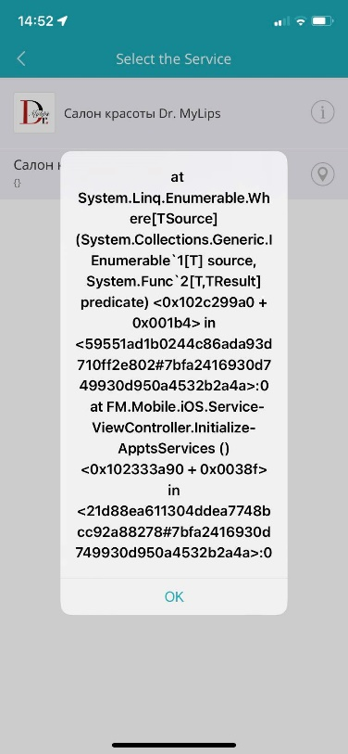

**Bug id - #2**

**Title –** Russian instead of English

**Precondition**

* Mobile internet or WiFi
* Installed Earlyone application

**Description**

The application language is English. But in some lines the data is written in Russian.

**Steps to reproduce**

1. Open Earlyone application
2. Choose “Beauty”
3. Click օn “Салон Красоты Black Barbie “

**Expected result**

The service page language should be English.

**Actual result**

In some lines the data is written in Russian.

**Environment**

iPhone XR

Operating system – iOS16.6

**Screenshots**

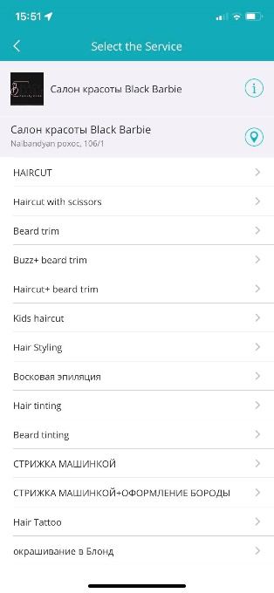 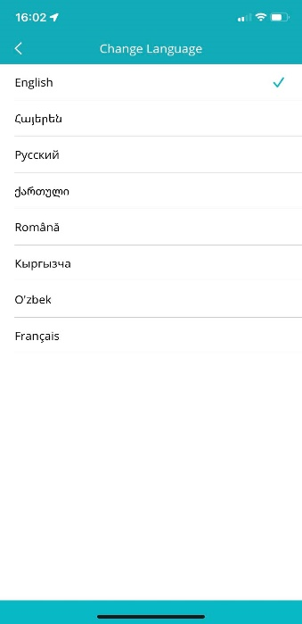

**Bug id - #3**

**Title –** Changing logo

**Precondition**

* Mobile internet or WiFi
* Installed Earlyone application

**Description**

The logo of Arabkir MC was modified in 2-3 seconds.

**Steps to reproduce**

1. Open Earlyone application
2. Click on “Healthcare”

**Expected result**

The logo corresponds to the medical center.

**Actual result**

There are 2 diffeerent logos of Arabkir MC.

**Environment**

iPhone XR

Operating system – iOS16.6

**Screenshots**

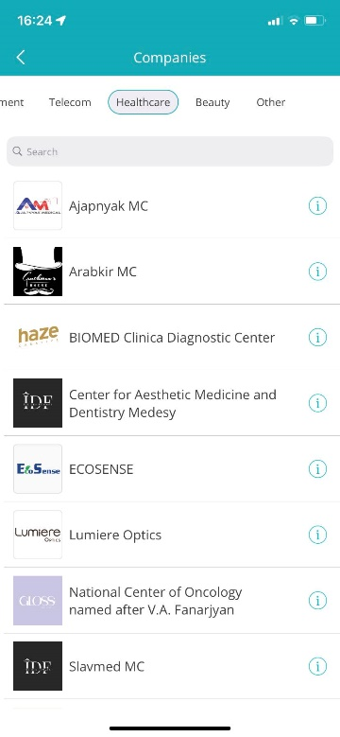 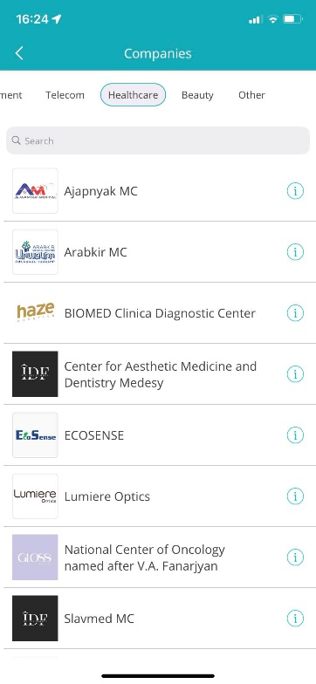

**Bug id - #4**

**Precondition**

* Mobile internet or WiFi
* Installed Earlyone application

**Description**

Showing pop-up “Booking is temporarily unavailable” instead of service list .

**Steps to reproduce**

1. Open Earlyone application
2. Click on “Healthcare”
3. Navigate to “ Arabkir MC”

**Expected result**

The page should show the service list of Arabkir MC.

**Actual result**

The page shows message “Booking is temporarily unavailable”.

**Environment**

iPhone XR

Operating system – iOS16.6

**Screenshots**

